Clarendon Federation

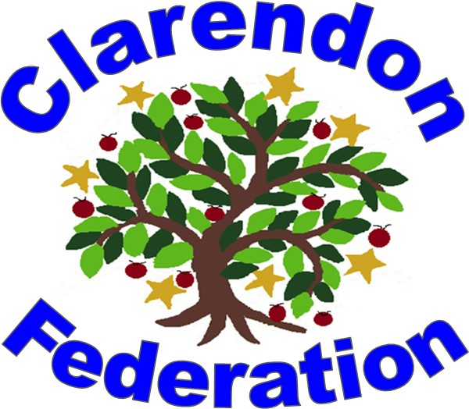

Personal, Social and Health Education Policy (PSHE)

Including Relationships Sex Education (RSE)

|  |  |
| --- | --- |
| Name of school | CLARENDON Federation SCHOOL |
| Date of policy | September 2024 |
| Member of staff responsible | MRS EVANS (Executive Head Teacher)  MRS ASHFORD-SMITH/MRS BROWN (Head of Schools)  MISS GILES (PSHE lead) |
| Review date | September 2027 |

|  |
| --- |
| **Aim** |

**We commit:**

1. **To work in partnership with parents and carers**. This will involve dialogue with parents and carers through all stages of policy development as well as discussing the resources used to teach their children and how they can contribute at home. It must, however, be recognised that the law specifies that what is taught and how it is taught is ultimately a decision for the school.
2. **That RSHE will be delivered professionally and as an identifiable part of R.S.H.E**. It will be led, resourced and reported to parents in the same way as any other subject. There will be a planned programme delivered in a carefully sequenced way. Any expert visitors or trainers invited into the school to enhance and supplement the programme will be expected to respect the schools published policy for RSHE.
3. **That RSHE will be delivered in a way that affords dignity and shows respect to all who make up our community.** It will not discriminate against any of the protected characteristics in the Equality Act 2010 and will be sensitive to the faith and beliefs of those in the wider school community. RSHE will seek to explain fairly the tenets and varying interpretations of religious communities on matters of sex and relationships and teach these viewpoints with respect. It will value the importance of faithfulness as the underpinning and backdrop for relationships. It will encourage pupils to develop the skills needed to disagree without being disagreeable, to appreciate the lived experience of other people and to live well together.
4. **That RSHE will seek to build resilience in our pupils to help them form healthy relationships, to keep themselves safe and resist the harmful influence of unreliable sources of information online**. It will give pupils opportunities to reflect on values and influences including their peers, the media, the internet and culture that may have shaped their attitudes to gender, relationships and sex. It will promote the development of the wisdom and skills our pupils need to make their own informed decisions.
5. **That RSHE will be based on honest and medically accurate information from reliable sources of information, including about the law and legal rights**. It will distinguish between different types of knowledge and opinions so that pupils can learn about their bodies and sexual and reproductive health as appropriate to their age and maturity.
6. **To take a particular care to meet the individual needs of all pupils including those with special needs and disabilities.** It will ensure that lessons and any resources used will be accessible and sensitive to the learning needs of the individual child. We acknowledge the potential vulnerability of pupils who have special needs and disabilities (SEND) and recognise the possibilities and rights of SEND pupils to high quality relationships and sex education.
7. **To seek pupils’ views about RSHE so that the teaching can be made relevant to their lives.** It will discuss real life issues relating to the age and stage of pupils, including friendships, families, faith, consent, relationship abuse, exploitation and safe relationships online. This will be carefully targeted and age appropriate based on a teacher judgment about pupil readiness for this information in consultation with parents and carers.

|  |
| --- |
| **Curriculum statement of Intent** |

**Intent**

At Clarendon Federation, consisting of Clarendon Infants and Junior School, PSHE enables our children to become healthy, independent and responsible members of society. Twinkl Life’s PSHE and Citizenship Scheme of Work aims to equip children with essential skills for life. It aims to develop the whole child through carefully planned and resourced lessons that develop the knowledge, skills and attributes children need to protect and enhance their wellbeing. Through these lessons, children will learn how to stay safe and healthy, build and maintain successful relationships and become active citizens, responsibly participating in society around them. Successful PSHE curriculum coverage is a vital tool in preparing children for life in society, now and in the future. Lessons in this scheme of work have their foundations in seeing each and everybody’s value in society, from appreciation of others in units such as Diverse Britain, to promoting strong and positive views of self in Think Positive and Be Yourself. Twinkl Life’s PSHE and Citizenship units aim to cover a wide range of the social and emotional aspects of learning, enabling children to develop their identity and self-esteem as active, confident citizens. The themes and topics support social, moral, spiritual and cultural development and provide children with protective teaching on essential safeguarding issues, developing the knowledge of when and how children can ask for help.

Twinkl Life’s PSHE and Citizenship resources are fully in line with the Learning Outcomes and Core Themes provided by the PSHE Association Programme of Study. This scheme of work covers all of the required objectives and follows the three core areas of Health and Wellbeing, Relationships and Living in the Wider World. The scheme of work fulfils the requirements of Statutory Relationships and Health Education, setting these learning intentions in the context of a broad and balanced PSHE curriculum.

**Implementation**

PSHE is taught across the school on a weekly basis either by the class teacher or a qualified PPA cover. Twinkl Life’s PSHE and Citizenship Scheme of Work is designed to be taught in thematic units consisting of six lessons. These units are taught in a spiral curriculum that revisits each theme every two years. This enables children to recall and build upon previous learning, exploring the underlying principles of PSHE education regularly at a depth that is appropriate for the age and stage of the child. Lessons signpost key words, building a rich vocabulary to develop understanding. Twinkl Life’s PSHE units are designed for delivery in a creative manner, using many approaches such as role play, discussion and games in groupings of various sizes. These activities enable children to build confidence and resilience. Work is recorded into a PSHE scrapbook.

**Impact**

Twinkl Life’s PSHE and Citizenship Scheme of Work provides schools with an effective curriculum for wellbeing. Children are enabled to develop the vocabulary and confidence needed to clearly articulate their thoughts and feelings in a climate of openness, trust and respect, and know when and how they can seek the support of others. They will apply their understanding of society to their interactions within communities, from the classroom to the wider community of which they are a part. Twinkl Life’s PSHE Scheme of Work supports the active development of a school culture that prioritises physical and mental health and wellbeing, providing children with skills to evaluate and understand their own wellbeing needs, practise self-care and contribute positively to the wellbeing of those around them.

Successful PSHE education can have a positive impact on the whole child, including their academic development and progress, by mitigating any social and emotional barriers to learning and building confidence and self-esteem. Evidence suggests that successful PSHE education also helps disadvantaged and vulnerable children achieve to a greater extent by raising aspirations and empowering them with skills to overcome barriers they face. The Twinkl Life PSHE and Citizenship Scheme of Work can be used as a whole-school approach to positively impact wellbeing, safeguarding and SMSC outcomes. This can ensure that all children can develop the knowledge, skills and attributes they need to succeed at school and in the wider world.

|  |
| --- |
| **Statutory requirements** |

This policy has been written in accordance with the statutory guidance document ‘Relationships and Sex education (RSE) and Health Education’ (DfE, 2019).

Department for Education guidance states that by the summer term 2021, all primary schools must teach relationships and Health Education. The teaching of Sex Education in primary schools remains non-statutory, with the exception of the elements of sex education contained in the science national curriculum: including knowledge of the main external body parts; the changes as humans develop to old age and reproduction in some plants and animals. Other related topics that fall within the statutory requirements for Health Education, such as puberty and menstrual wellbeing, will be included within PSHE education lessons.

Within the statutory guidance document for RSE and Health Education, the DfE also encourages schools to deliver age-appropriate sex education if they feel their pupils need this education.

*‘It will be for primary schools to determine whether they need to cover any additional content on sex education to meet the needs of their pupils. Many primary schools already choose to teach some aspects of sex education and will continue to do so, although it is not a requirement…’*

*‘It is important that the transition stage before moving to secondary school supports pupils’ ongoing emotional and physical development effectively. The Department continues to recommend therefore that all primary schools should have a sex education programme tailored to the age and the physical and emotional maturity of the pupils. It should ensure that both boys and girls are prepared for the changes that adolescence brings and – drawing on knowledge of the human lifecycle set out in the national curriculum for science – how a baby is conceived and born.’*

In teaching PSHE, we are required by our funding agreements to have regard to the guidance issued by the secretary of state as outlined in section 403 of the Education Act 1996.

|  |
| --- |
| Relationships and Sex Education (RSE) |

**Definition**

Within this policy, as in the DfE guidance, relationships Education is defined as teaching about the fundamental building blocks and characteristics of positive relationships, with particular reference to respectful friendships, family relationships, and relationships with other children and with adults, including online.

For the purpose of this policy, Health Education is defined as teaching pupils about physical health and mental wellbeing, focusing on recognizing the link between the two and being able to make healthy lifestyle choices.

Sex Education is defined as teaching children how human reproduction occurs, including how a baby is conceived and born. This draws on knowledge of the human lifecycle as set out in the national curriculum for science. For the purposes of this policy, we specifically identify any non-statutory Sex Education that falls outside of Science and those elements (the physical changes associated with puberty) within statutory Health Education. RSE is not about the promotion of sexual activity.

RSE is about the emotional, social and cultural development of pupils, and involves learning about relationships , sexual health, sexuality, healthy lifestyles, diversity and personal identity.

RSE involves a variety of sharing information, and exploring issues and values.

**Curriculum and Delivery of RSE**

RSE is taught mainly through our Twinkl PSHE programme, however some sex education is taught through science where it contributes to their knowledge and understanding. Relationships and Sex Education is learning about the emotional, social and physical aspects of puberty, relationships and health.

RSE aims to equip children and young people with the information, skills and values which they will need to lead safe, fulfilling, enjoyable relationships and which will help them go on, beyond primary school, to take responsibility for their sexual health and wellbeing.

In line with the DfE 2019 Guidance, the focus of RSE at Clarendon Federation will be on teaching the fundamental building blocks and characteristics of positive, healthy, respectful relationships, with particular reference to friendships, family relationships, and relationships with other children and with adults in all contexts, including online. This will sit alongside the essential understanding of how to be healthy and how totally interlinked physical and mental health are.

Research has shown that a comprehensive RSE curriculum can help young people to feel more positive about themselves and to understand what a healthy relationship looks like, as well as to delay the age at which they become sexually active. Young people who feel good about themselves are more knowledgeable and confident about relationships, more likely to be more discerning in their relationships and sexual behaviours and also more likely to have healthy, safe and fulfilling relationships.

Keeping Children Safe in Education (KCSIE) 2022 sets out that all schools and colleges should ensure children are taught about safeguarding, including how to stay safe online, as part of providing a broad and balanced curriculum, and our RSE curriculum at Clarendon Federation is key to this provision. If any disclosures or concerns are raised during these lessons staff must follow the school procedures for child protection and safeguarding alerting the DSL.

# Role of parents in PSHE/RSE

The primary role in children’s sex education lies with parents and carers. The school wishes to build a positive and supporting relationship with the parents/carers of children through mutual understanding, trust and cooperation. In promoting this objective, we:

* Inform parents about the school’s policies and practice.
* Answer any questions parents may have about the sex education of their child.
* Take seriously any issue that parents raise with teachers of governors about this policy or the arrangements for sex education in the school.
* Inform parents about the current best practice known with regard to sex education, so that teaching in school supports the key messages that parents and carers give to children at home.

Through this mutual exchange of knowledge and information, children will benefit from being given consistent messages about their changing body and their increasing responsibilities.

# Parents’ right to withdraw

# The right of withdrawal from September 2020

# The statutory guidance for Relationships Education and Health Education will come into effect in all primary schools from 2020, including academies, free schools and independent schools.

# In primary education from September 2020:

# Parents will not be able to withdrawn their children from any aspect of Relationships Education or Health Education (which includes learning about the changing adolescent body and puberty).

# Parents will be able to withdraw their children from any aspects of Sex Education other than those which are part of the science curriculum. (Note that sex education will not be statutory in primary schools, however the new statutory guidance makes clear that schools should still provide a programme of age appropriate se education).

# Head teachers in primary schools must grant requests to withdraw a pupil from sex education, other than where it is part of the science curriculum (although the guidance makes clear that good practice is ‘*likely to include the head teacher discussing with parents the benefits of receiving this important education and any detrimental effects that withdrawal might have on the child’).*

# Where pupils are withdrawn from sex education, schools should document the process and will have to ‘*ensure that the pupil receives appropriate, purposeful education during the period of withdrawal.’*

# The Relationships Education, RSE, and Health Education (England) Regulations 2019 have made Relationships Education compulsory in all primary schools from September 2021. (Delayed from scheduled 2020 due to COVID pandemic).

|  |
| --- |
| **Ground rules** |

Teachers are careful to ensure that their personal beliefs and attitudes do not influence the teaching of RSE. To this end, ground rules are always agreed upon to provide a common values framework within which to teach. There are clear parameters as to what will be taught in whole class setting and what will be dealt with on an individual basis.

Ground rules will ensure that:

* Pupils are given preparation so that they will know how to minimise any embarrassment they feel.
* No one (teacher nor pupil) should be expected to answer a personal question.
* No one will be forced to take part in a discussion.
* The school’s confidentiality/safeguarding policies are adhered to.

# Answering difficult questions

When delivering the RSE objectives teachers will always consider how children of the same age may be developmentally at different stages, leading to differing types of questions or behaviours. Teaching methods should take account of those developmental differences (including when these are due to specific special educational needs or disabilities) and recognise the potential for discussion on a one-to-one basis or in small groups. Schools should consider what is appropriate and inappropriate in a whole-class setting, as teachers may require support and training in answering questions that are better not dealt with in front of a whole class. On occasion, an individual child will ask an explicit or difficult question in the classroom. Questions do not always have to be answered immediately; it may be more appropriate to address them later.

# Dealing with questions

* Teachers should establish clear parameters about what is appropriate and inappropriate in a whole-class setting.
* Teachers should set the tone by speaking in a matter-of-fact way and ensure that pupils discuss issues in a way which does not encourage giggling and silliness.
* Pupils should be encouraged to write down questions

anonymously and post them in a ‘problem/worry box’. The teacher will then have time to prepare age-appropriate answers to all questions before the next session and will choose not to respond to any questions which are inappropriate.

* Teachers should respond to questions where they can, always bearing in mind that pupils who do not have their questions answered may go online to find answers.
* Teachers should not be drawn into providing more information than is appropriate to the age of the child.
* If a verbal question is too personal, the teacher should remind the pupils of the ground rules.
* If a question is too explicit, feels too old for a pupil, is inappropriate for the whole class or raises safeguarding concerns, the teacher should acknowledge the question and promise to attend to it later, on an individual basis.
* If a teacher is concerned that a pupil is at risk of sexual abuse the head teacher should be informed and the usual safeguarding/child protection procedures followed.

# Progression

The PSHE and RSE curriculum is delivered in a progressive and age appropriate manner. Key aspects such as forming positive friendships and staying safe online will be revisited over time to ensure that the approach is progressive and appropriate for those children at that point in time. There is a clear pathway of progression across the school to ensure that skills are built on and constantly further developed.

|  |
| --- |
| Inclusion |

**Differentiation and Additional Educational Needs**

PSHE will be planned to give pupils a suitable range of differentiated activities appropriate to their age and abilities. For pupils with SEN the task will be adjusted or pupils may be given extra support. The grouping of pupils for practical activities will take account of their strengths and weaknesses and ensure that all take an active part in the task and gain in confidence.

# Equality of Opportunity

All children have equal access to the PSHE curriculum. All staff at Clarendon Federation are responsible for ensuring that all children, irrespective of gender, learning ability, physical disability, ethnicity and social circumstances, have access to the whole curriculum. Where appropriate, work will be adapted to meet pupils’ needs and, if appropriate, extra support given. More able pupils will be given suitably challenging activities. Gender and cultural differences will be reflected positively in the teaching materials used. All children have equal access to the PSHE Curriculum, its teaching and learning, throughout any one year.

|  |
| --- |
| **Assessment and Feedback** |

**Assessment**

Throughout the school, when appropriate, teachers will assess whether children are working at, above or below the expected level for their age based on their understanding and application of the content. The children’s progress and attainment are reported on Insight.

|  |
| --- |
| **Subject Monitoring** |

**Role of the Subject Leader**

PSHE will be led by the Subject Leaders at both the Infant and Junior school, who will monitor progression and impact through:

* monitoring and evaluation of pupils’ work
* lesson observations
* discussions with the children

Standards of teaching and learning will be monitored using work sampling, observations and learning walks.

The policy will be amended and renewed by the subject lead as appropriate and shared and reviewed during a staff meeting.

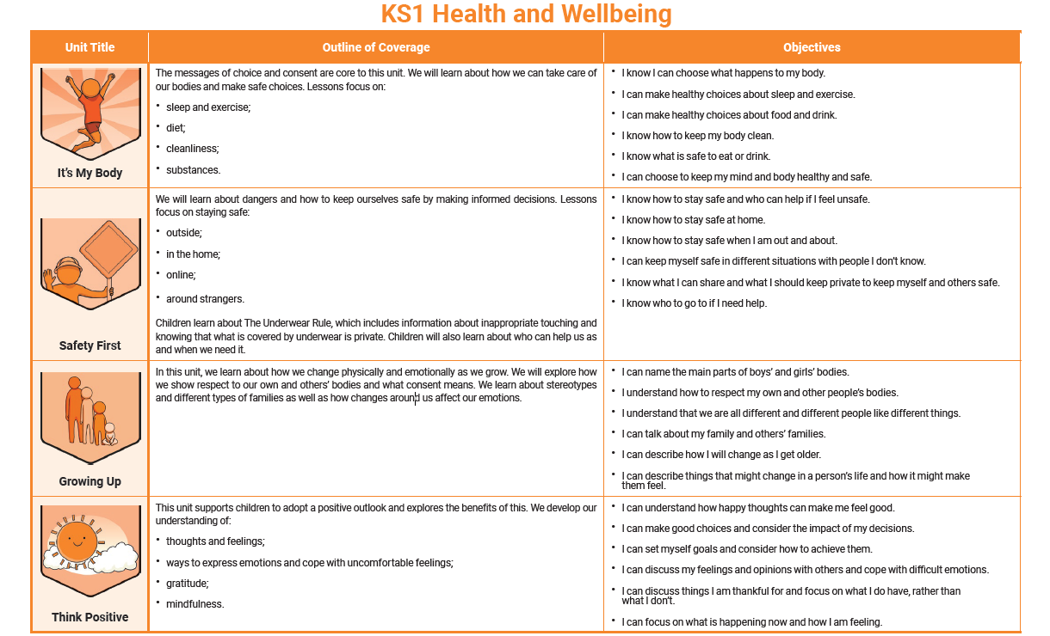**Appendix 1 – PSHE Content Map**

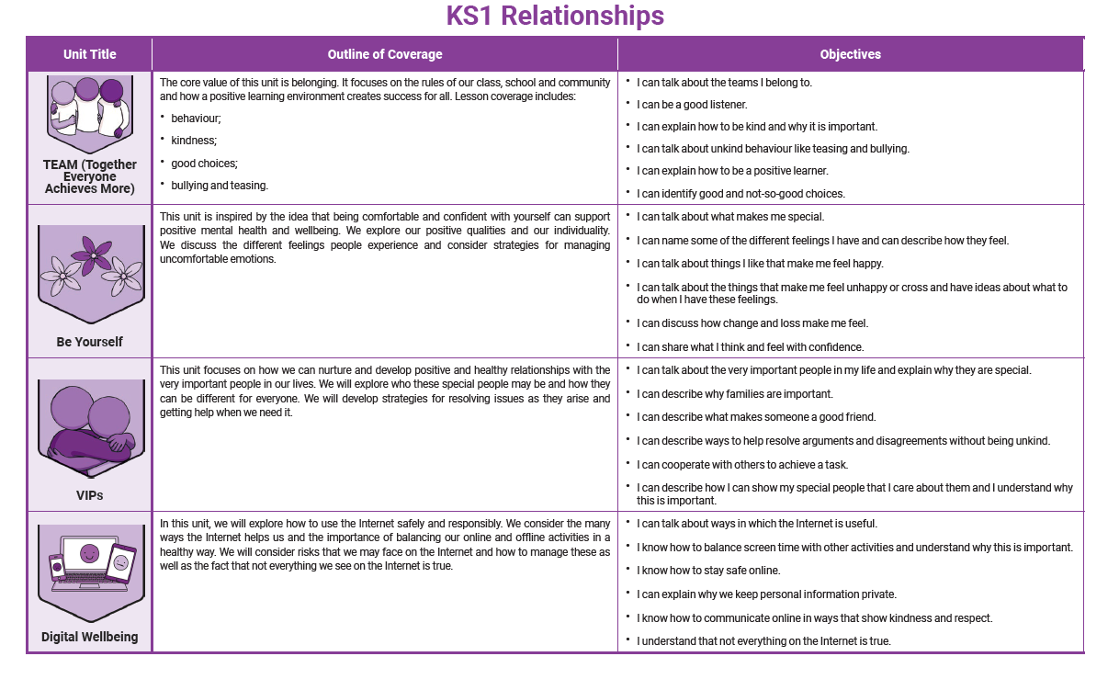

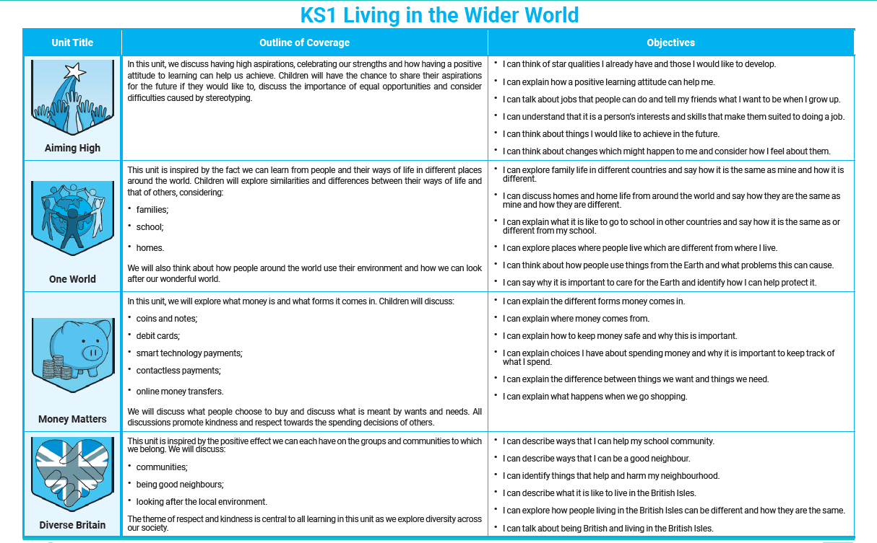k

